CS206 Remote SQL Connection to Customers206 DB on Winhost.com
PW=cs206
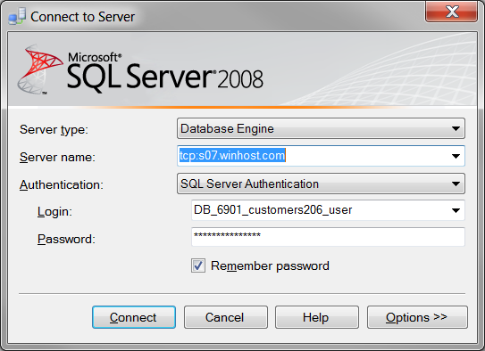
When creating a new connection string in VS 2010, use this info in the DB wizard. Your connection string in web.config should be:
"Data Source=tcp:s07.winhost.com;Initial Catalog=DB_6901_customers206;User ID=DB_6901_customers206_user;Password=******;Integrated Security=False;"

