USING LIST BOXES STEP 3

This shows how to allow multiple selections from one LB to another.
Make sure to set the selectionmode property of the first LB to MultiExtended.
It also shows how to use the foreach loop to cycle through the selectedItems Collection
Also Stops duplicates from being added to the cart.

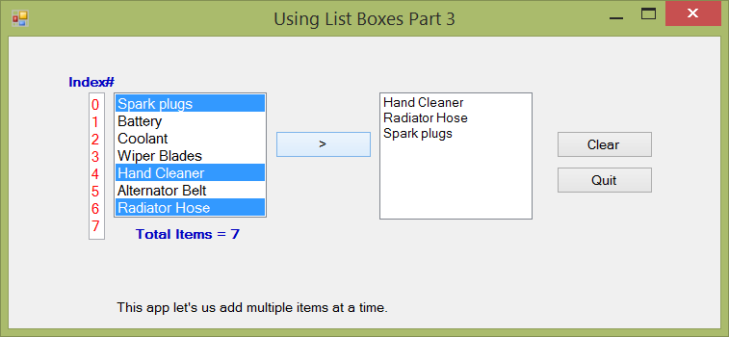

private: System::Void btnAdd_Click(System::Object^ sender, System::EventArgs^ e)
{
/*---now cycle through the selected items collection and send them to the other list box. SelectedItems is created for us when the program runs by the listbox itself...it keeps track of what they chose. Then all we have to do is to read through that list and do something with them. This SelectedItems Collection is only available to us at run-time. Not design time.
*/

for each (String^ myItem in lstItems->SelectedItems)
{

if (lstPurchased->Items->Contains(myItem) == false) //avoid duplicates
lstPurchased->Items->Add(myItem);
}

}

private: System::Void btnClear_Click(System::Object^ sender, System::EventArgs^ e)

{
lstItems->SelectedItems->Clear();
lstPurchased->Items->Clear();
}

