Santiago Canyon College
Computer Science 120
Ron Kessler
Lesson 6: 3- Introduction to Custom Classes
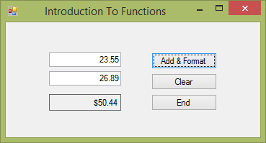

This project shows how to:
- Add a new class to an existing project. Be sure to select Add | Class from your project. This opens the wizard.
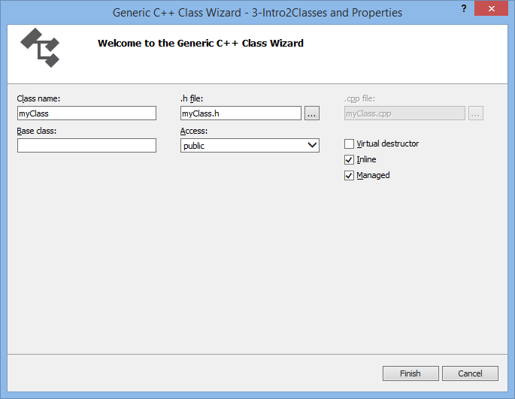
- Give it a name and check Inline. This makes a .h file only. Managed makes it a managed code class.
- Your new class shows up under the Header files in Solution Explorer.
  - You want to add the following to your new class. Here is an example of my DoMath class:

#pragma once //add this

#include "Form1.h" // make sure to reference the form where we will be calling this class from

Add These
using namespace System;
using namespace System::Windows::Forms; // so we can use messagebox

//make sure the class is public. It is created as private by default!

public ref class DoMath sealed
{
public:

DoMath(void)
{
}

- Now go into the Source Files in Solution Explorer and open your projects .cpp file. It will have the same name as your project. Add a compiler directive to add your new class after the ones that are already there.
#include "stdafx.h"
#include "Form1.h"
#include "DoMath.h"

- Now you should be able to reference your new class from your main form.
- I use the TryParse methods we used in the previous project.

